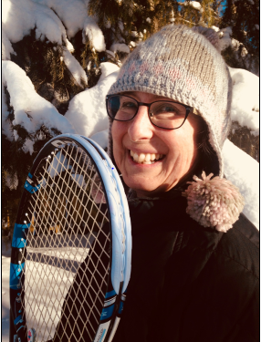

Wells: A New Fan Favorite Breaks Through At the Aussie Open

Su-Wei Hsieh’s Unconventional Style Delights Fans
On January 21 at the Australian Open, Su-Wei Hsieh of Taiwan took on the highly favored Angelique Kerber of Germany on the Rod Laver arena. The result, to the surprise of many, was a close and highly entertaining match. Su-Wei Hsieh gave Kerber, and fans, a two-hour battle to remember. Even the TV announcers were baffled by Su-Wei's success, at one point describing her technique as "club level", and her clothing as lacking labels.
Between the announcers AND the tennis, this was one of the most entertaining women’s matches of the tournament. Other writers’ comments confirm the sentiment:
“A quirky magic”
“No one plays tennis like Hsieh”
“She made it look easy”
“Intelligent and creative ”
“A bewitching combination of unorthodox double-handed strokes and clever spin.”
"The first 90 minutes of that match were some of the most fun I've ever had with tennis"
(Ben Rothenberg tweet, January 21)
Hsieh’s style was refreshing for fans of women’s pro tennis, where steely looks, screams and grunts, and bashing ground strokes are the meat and potatoes of matches. The match began with Hsieh commanding the first set at 6-4, a strong start. In the second set, Hsieh had her chances, but Kerber pulled out the victory at 7-5 to force a third set. The swelling tide of Kerber continued in the third set, and she took it handily at 6-2, with Hsieh fighting fatigued. No wonder she was tired. Hsieh had played eight days in a row between singles and doubles events. After the Kerber match, she continued her drive to the semi-finals in doubles with long-time partner Peng Shui of China, making ten consecutive days of match play.

What was so refreshing about Hsieh?
- Demeanor—She looks relaxed and has fun on the court. Her post-match press conference was upbeat.
- Two-handed forehand and backhand—Her elbows barely leave her side. Her stroke is like a forearm roundhouse on both sides.
- One-handed forehand and backhand—If the ball is too far away, she easily transitions from two-handed to one-handed strokes.
- Drop-shot overheads—She can smash a high ball, or she can drop it just over the net, surprise!
- Winners to back corners—She hits the back corners at will with a medium-paced ball.
- Efficient movement—At times she looks attached to the middle of the court. When necessary, she can run a ball down as well as anyone.
- Free style—During the post-match press conference she referred to “Su-wei style”, doing what comes naturally, without a game plan.
- Variety—She can spin, slice, drop, drive, smash and place.
- Box—A mix of gender, age, and ethnicity, along with one super-fan who was a go-to for the cameras.

Who is this girl? Quick facts about Su-Wei Hsieh.
- Same height as Kerber at 5’7”, but weighs twenty-five pounds less tat 125 pounds.
- Ranked 88 in singles and 34 in doubles at the time of the Australian Open.
- Turned pro in 2000.
- 32 years old.
- Highest singles ranking of #25 in 2012, and highest doubles ranking of #1 one in 2014.
- To reach the Kerber match in the Round of 16, she won against Muguruza in the 2nd round (7-6, 6-4), and Radwanska in the third round (6-2, 7-5).
- Only other top 10 singles win before the AO was against Johanna Konta in the 2017 French Open.
- Best previous singles result at the AO was fourth round in 2008, ten years ago.
That week at the AO, Su-Wei Hsieh was joined in the Round of 16 by Asian players Naomi Osaka of Japan (women's) and Hyeon Chung of South Korea (men's). Earlier, En Shuo Liang from Taiwan had taken first place in girls’ singles. This Asian momentum is attributed to Li Na, the first Asian player to win a Grand Slam title at the French Open in 2011, repeating three years later at the Australian Open. If the Hsieh/Kerber match is an indication, Asian players will boost the tour's entertainment value this year.
Su-Wei Hsieh's memorable performance at the AO was further acclaimed this week as she was named the WTA Breakthrough Player of the Month for January 2018, as voted by fans. Her "club level" technique has served her well. For tennis, The Kerber/Hsieh match showcased the diversity in technique, style, personality and country that makes this the best sport in the world.

https://twitter.com/wta/status/959517552924856321

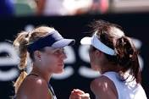

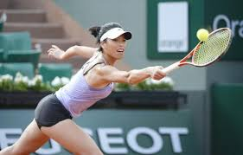

v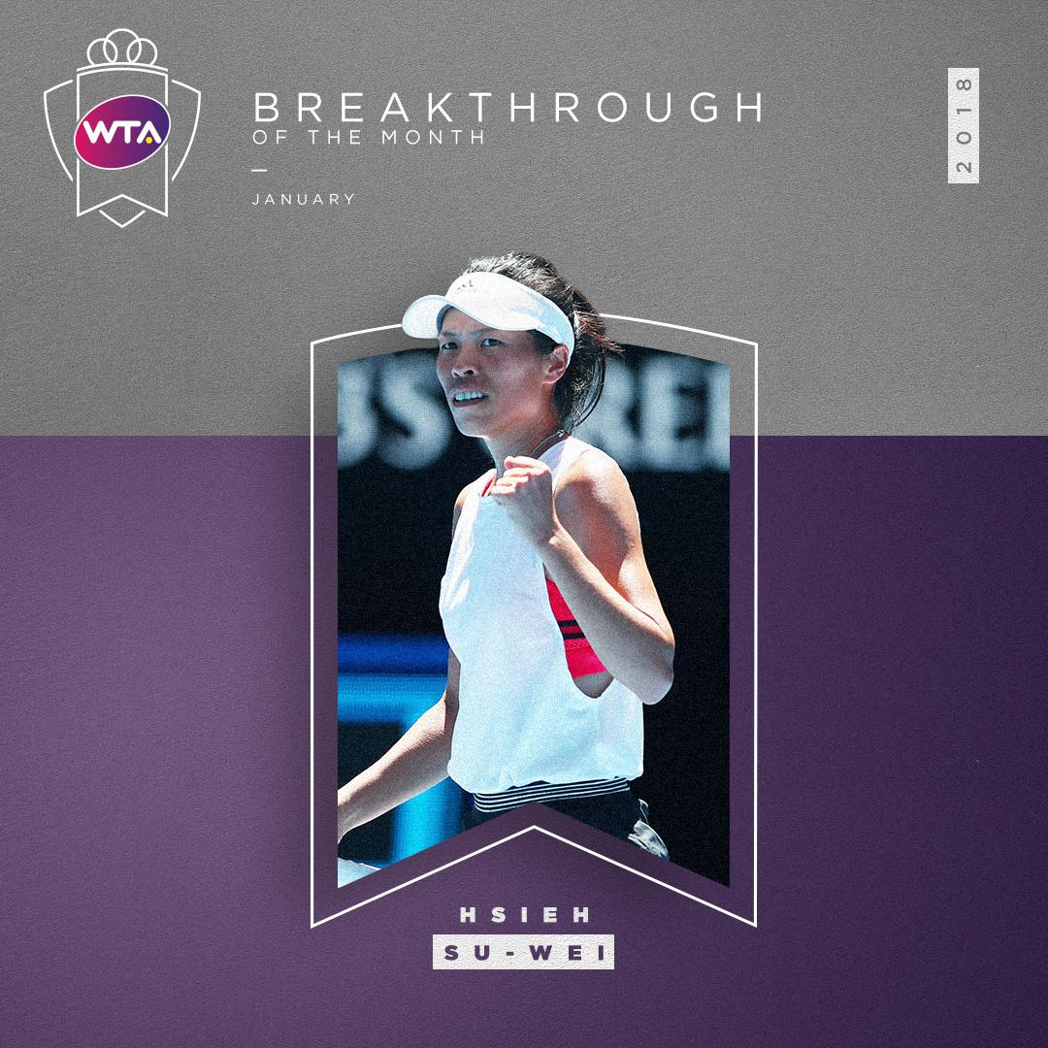

Alberta Juniors In The Canadian Top Ten
Upcoming Tournaments in Edmonton and Calgary For Top Juniors
Hold on to your rackets. For two weekends in February, Alberta’s best junior players will go head-to-head. The MNP Junior Champs U 12 and U16 will be hosted by Edmonton on February 8-11 at the Royal Glenora Club. Then the next weekend Calgary hosts the MNP Junior Champs U14 and U18 on February 15-18 at the Alberta Tennis Centre.
Alberta currently boasts one Junior player in the top 10 in Canada, and 8 in the top 20. After the February tournaments are said and done, who knows, we may double our numbers and have two in the top ten!
Our top ten national Junior player is Nawal Issam Youssef, currently ranked #8 in Canada in the U12 girls division. Way to go Nawal! Other top 20 players include two others with Nawal in the U12, four in the U14, and one in U18—four boys and four girls.
Good luck in the February tournaments to all the players, and especially to juniors approachig a top ten national ranking:
- Nawal Issam Youssef (U12 girls)—congratulations on your national ranking of 8th. You are in the top 10!
- Joshua Oboniye (U14 boys)—one place to go, currently ranked 11th in Canada.
- Mia Kupres (U14 girls)—so close to top ten, currently ranked 12th nationally.
- Gianna Oboniye (U12 girls), Kai Baerg (U12 boys), and Cleeve Harper (U18 boys) —all currently ranked 15th in their age divisions, in Canada.
- Tyler Waddock (U14 boys)—at #18 in Canada.
- Martyna Ostrzygalo (U14 girls) —#20 in Canada.
Enjoy the journey, remember “it’s only tennis” (quote from Roger Federer during a post-match interview at the 2018 Australian Open), handle losses as well as wins, and consider that your best teacher is your last mistake. Fans are welcome to drop by the Royal Glenora in Edmonton (Feb. 8-11) and the Alberta Tennis Centre in Calgary (Feb. 15-18) for some entertaining tennis. Tennis Alberta’s web site will have up-to-date results and game times. LINK

Mother Tennis on Keeping Perspective
I am tennis, some call me Mother Tennis. I am proud to have you as part of my family. I want to draw your attention to some wise words of Mr. Roger Federer, to whom I granted my highest level of skill, along with passion, ambition, and good sense.
During his post-match interview after an Australian Open game, Mr. Federer said to the interviewer, “It’s only tennis, after all.” Now I as Mother Tennis could have taken this as a bit of a slight, but I certainly did not. Roger was reminding his tennis family friends that they are engaged in the pursuit of a little green ball. Tennis players do not heal people, help the environment, end wars, or interpret the laws of the land. They simply chase balls, albeit with passion and purpose.
I am proud that I help to keep you fit and healthy, teach you many lessons about people and life, and provide fun and enjoyment to millions. Ultimately, I am a fuzzy ball, a stick, some rope, some lines, and some rules. Even though I am the best sport in the world, Roger reminded me and all of us to keep perspective, “It’s only tennis.” Swing on and have fun. Mother Tennis

